BFK-312C
Fitness Band for Kids
User Manual
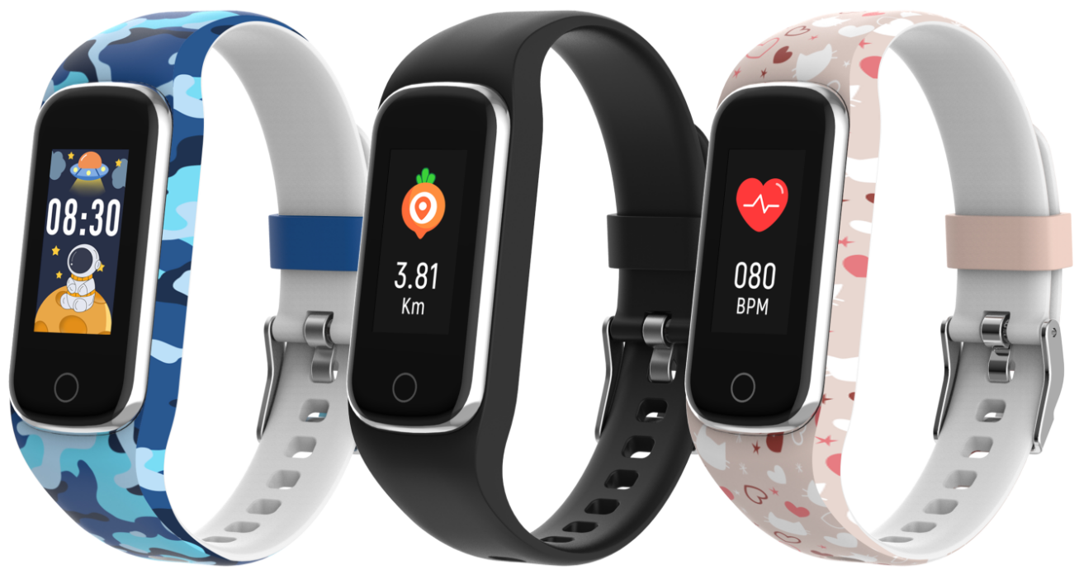
www.denver.com
www.facebook.com/denver.eu
ENGLISH
If the user manual is not printed in your local language, please visit our website to see if it is available online for the device you have. Our website address is: www.denver

Safety information

Please read the safety instructions carefully before using the product for the first time and keep the instructions for future reference.

1. Warning: This product contains lithium polymer battery.
2. Product operating and storage temperature is from 0 °C to 40 °C. Exceeding this temperature range might affect the function.
3. Never open the product. Repairs or service should only be performed by qualified personnel.
4. DO NOT use the product in water beyond a depth of 2 meters or longer than 30 minutes.
5. Please remove the Smart fitness band in case of any leakage or excessive heat from the product to avoid burns or rash.
6. Bluetooth wireless technology can only operate within a range of about 10 m (30 ft). The maximum communication distance may vary depending on the presence of obstacles (people, metal objects, walls, etc.) or the electromagnetic environment.
7. Microwaves emitted by a Bluetooth device may affect the operation of electronic medical devices.
8. Only charge the product with the supplied USB cable.
9. Keep product out of the reach of pets to avoid chewing and swallowing.

In the box
- 1 x Fitness Band
- 1 x Charging Cable
- 1 x User’s Guide

- Product Overview
① Touch button: Press / press and hold for more functions
② Heart rate sensor
③ Charging contacts
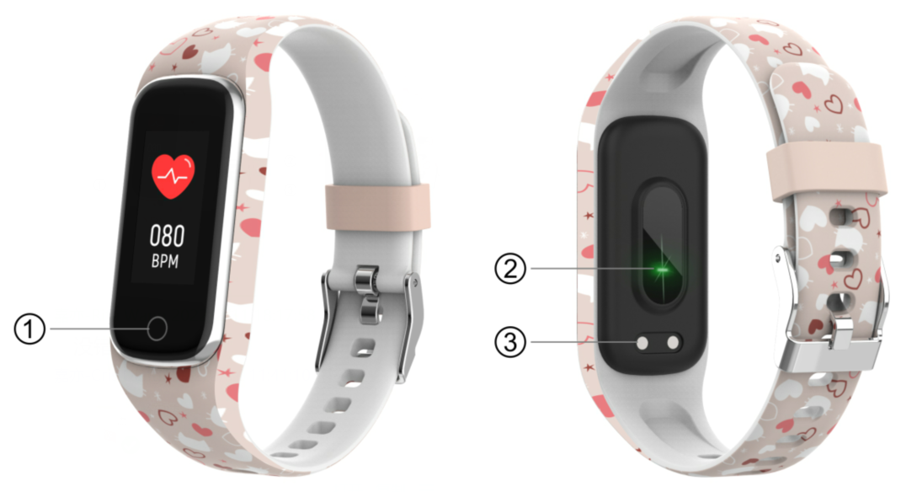

- Smart fitness band Charging
- Before using your smart fitness band for the first time, please make sure it is fully charged.
- It takes approximately 2 hours to fully charge the product. Once a power charger is connected, the smart fitness band will charge automatically.
- Make sure that the charging pins on the charging cable fit correctly onto the charging contacts at the back of your smart fitness band, then connect the other end to a power source.
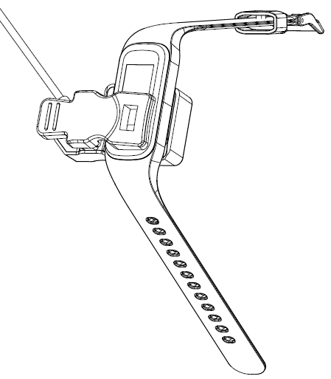
4. Install, Connect or Disconnect the App
- Before downloading the “Fit4Kid” app, make sure that it is compatible with your smartphone. The app works with iOS 10.0 or above and Android 5.0 or above.
- Search for the “Fit4Kid” app in the App Store or Google Play or scan the following QR code to install.
- Turn on Bluetooth on your smartphone, open the “Fit4Kid” app and set your profile. Then tap “Connect Smartwatch” in settings and choose your smartwatch to connect.
- To disconnect your smartwatch, go to the app settings and tap “Disconnect Smartwatch”. For iPhone, you also need to go to “Bluetooth” in your iPhone Settings, then tap “Forget This Device”.

5. Use Instructions
Press and hold the Touch button for 3 seconds to turn on the smart fitness band; press the Touch button again to see more functions.
6. Main Menu
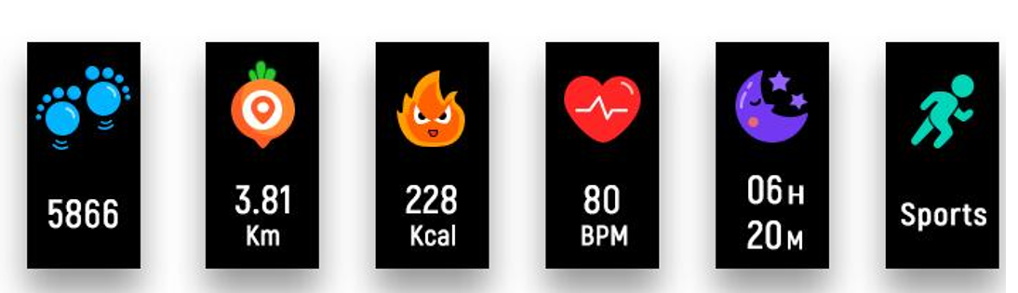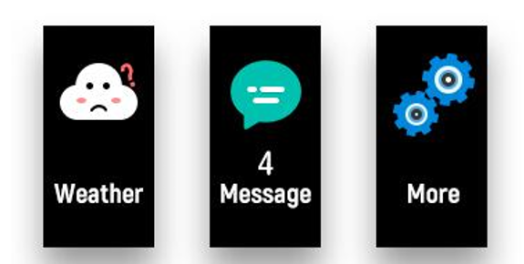

7. Switch Clock Face
After turning on the smart fitness band, the clock face is displayed. Press and hold the Touch button to choose a different clock face.
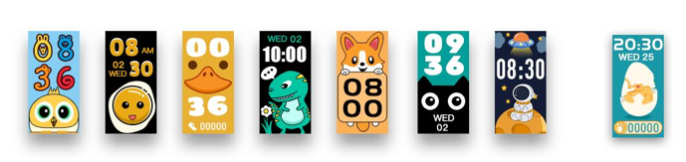

8. Daily Activity
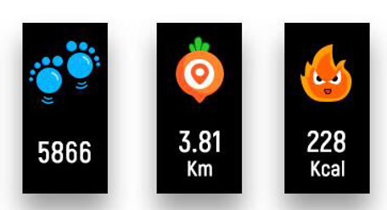
The fitness band will record your daily activity automatically. Press the Touch button to check steps, calories, and distance.

9. Heart Rate
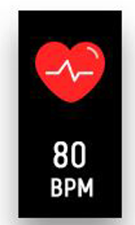
Press the Touch button to switch to the heart rate monitoring interface.

10. Sleep Monitoring
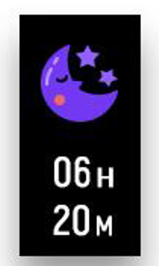
If you wear the smart fitness band to bed, it will automatically monitor your sleep quality. If your smart fitness band is connected to the “Fit4Kid” app via Bluetooth, you can also check a more detailed sleep report in the app.
11. Sports 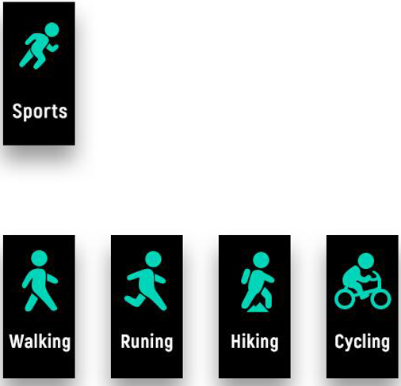
Press the Touch button to switch to the sports interface, then press and hold the Touch button to choose a sport mode. To exit the sport mode, press and hold the Touch button to finish your sport and save the sports data.
Please note your sports data will not be saved if there is very few exercise data.

12. Messages
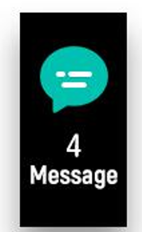
Press the Touch button to switch to the message interface, then press and hold the Touch button to enter and check your phone calls, SMS, QQ, WeChat, WhatsApp, Facebook, Twitter notifications, and etc. The messages will be automatically deleted after you read them.

13. Weather
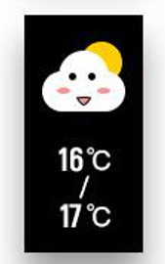
The fitness band will display the weather forecast when it is connected with the app.

14. Settings
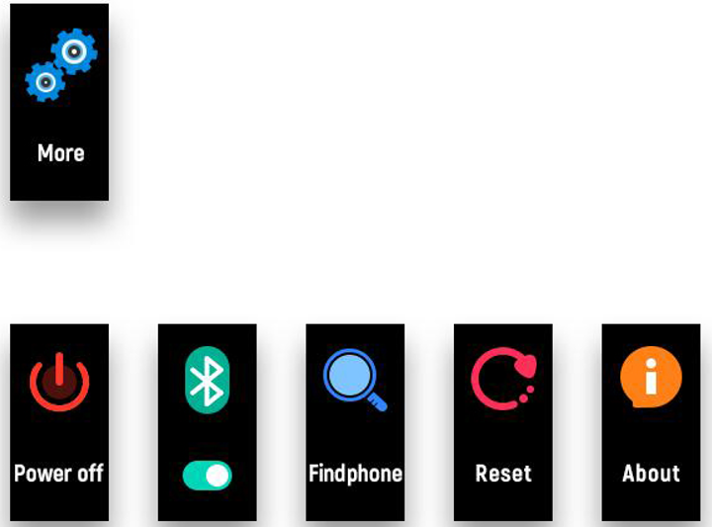Press the Touch button to switch to the “More” interface, then press and hold the Touch button to enter:

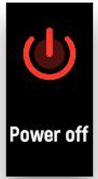Press and hold the Touch button to shut down.

About: To view the MAC address, BT name, and software version of your smart fitness band.
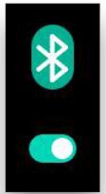 Press and hold the Touch button to turn on /off Bluetooth.

After the fitness band is connected to Fit4Kid, press and hold the Touch button to find your smartphone.

Reset: All data on the fitness band will be cleared.

Please notice - All products are subject to change without any notice. We take reservations for errors and omissions in the manual.

ALL RIGHTS RESERVED, COPYRIGHT DENVER A/S
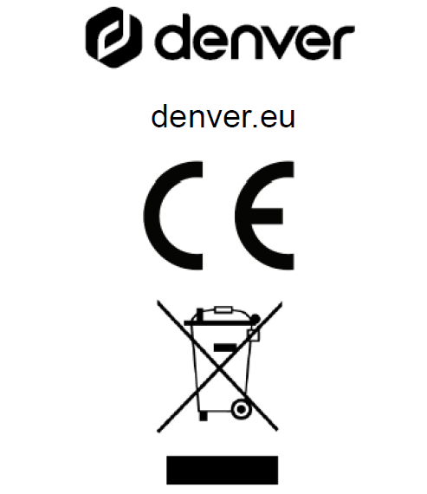
Electric and electronic equipment and included batteries contains materials, components and substances that can be hazardous to your health and the environment, if the waste material (discarded electric and electronic equipment and batteries) is not handled correctly.
Electric and electronic equipment and batteries is marked with the crossed out trash can symbol, seen above. This symbol signifies that electric and electronic equipment and batteries should not be disposed of with other household waste but should be disposed of separately.

As the end user it is important that you submit your used batteries to the appropriate and designated facility. In this manner you make sure that the batteries are recycled in accordance with legislature and will not harm the environment.

All cities have established collection points, where electric and electronic equipment and batteries can either be submitted free of charge at recycling stations and other collection sites or be collected from the households. Additional information is available at the technical department of your city.

Hereby, Denver A/S declares that the radio equipment type BFK-312C is in compliance with Directive 2014/53/EU. The full text of the EU declaration of conformity is available at the following internet address: denver.eu and then click the search ICON on topline of website. Write model number: BFK-312C. Now enter product page, and RED directive is found under downloads/other downloads.
Operating Frequency Range: 2.402~2.480 GHz
Max. Output Power: -0.91 dBm

DENVER A/S
Omega 5A, Soeften
DK-8382 Hinnerup
Denmark
www.facebook.com/denver.eu

