**USER** **MANUAL**

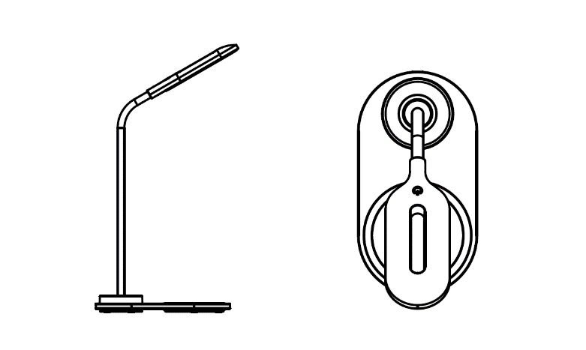

**Desk Lamp with Wireless Charger**

**Instructions**

1. Connect the wireless charger with an AC power source by means of a power adapter **(not included)**, then the wireless charger turns on, and the indicator light will turn blue in 3 seconds and then turn green in 15 seconds before it turns off. The charger is now in standby mode.

2. Place your phone onto the wireless charging area, then the phone will begin to charge, and the indicator light will display a flashing blue color at the same time. Once the phone is fully charged, the blue indicator light will stay illuminated. Ensure you position the phone correctly to initiate charging. (This will be indicated on the phone as well)

3. Tap the touch lamp switch (on top), and the lamp will turn on. The lamp has 3 types of lighting modes, warm, cold, and mixed, which you can switch between by using additional touches. A 4th touch will turn the lamp off.

**Specifications**

Input: 5V 2A

Output: 5V 1A

CRI: 85 max

Lamp Power: 1.5W

Color temperature: 2700K-6500K

3 color temperature: 2700K-6500K

Touch control

5W QI charging

Please notice - All products are subject to change without any notice. We take reservations for errors and omissions in the manual.

ALL RIGHTS RESERVED, COPYRIGHT DENVER ELECTRONICS A/S



Electric and electronic equipment contains materials, components and substances that can be hazardous to your health and the environment, if the waste material (discarded electric and electronic equipment) is not handled correctly.

Electric and electronic equipment is marked with the crossed out trash can symbol, seen above. This symbol signifies that electric and electronic equipment should not be disposed of with other household waste, but should be disposed of separately.

All cities have established collection points, where electric and electronic equipment can either be submitted free of charge at recycling stations and other collection sites, or be collected from the households. Additional information is available at the technical department of your city.

DENVER ELECTRONICS A/S

Omega 5A, Soeften

DK-8382 Hinnerup

[www.facebook.com/denverelectronics](http://www.facebook.com/denverelectronics)